**Intro to JS**

**Task 1**. You need to find all numbers between the first and second numbers.

Workflow:

1. User inputs the first number. (Use “prompt” function).
2. User inputs second number. (Use “prompt” function).
3. You need to validate the input data: two values should be numbers, the first number can’t be bigger than the second.
4. If input data is not valid, you should show message “Invalid input data”. (Use “alert” function).
5. You need to find all numbers between the first and second numbers
6. Show message: (example). Use ”alert” function

Example:

First number: 5

Second number: 10

Numbers between : 6 7 8 9

**Task 2**. Your task is to write a simple simulator of casino roulette.

Requirements:

Step 1:

* Create a prompt window (use confirm()). Show the message inside the window ‘Do you want to play a game?’.
* In case the user clicks the 'Cancel' button, the message 'You did not become a billionaire, but can.' should be shown (use alert).

Step 2:

* If user clicked ‘Ok’ – start a game: randomly (use Math.random()) choose an integer number in range [0; 8] (including 0 and 8) and ask user to enter a number of pocket on which the ball could land (use prompt()).
* User has 3 attempts to guess a number.
* If user guessed the number on which ball landed, on 1-st attempt prize is 100$ (maximum prize for current numbers range), 2-nd attempt – 50$, 3-rd attempt – 25$.
* If user did not guess a number show the message ‘Thank you for your participation. Your prize is: … $’ (Use alert) and ask if he wants to play again (use confirm).

Step 3:

* If user did guess - Show the message ‘Congratulation, you won! Your prize is: … $. Do you want to continue?’.
* If user does not want to continue – show the message ‘Thank you for your participation. Your prize is: … $’ (Use alert) and ask if he wants to play again (use confirm).
* If user does want to continue, make number range bigger at 4 as the previous one (for example [0; 8] -> [0; 12]), and two times bigger maximum prize (for example on 1-st attempt prize will be 200$, 2-nd attempt – 100$, 3-rd attempt – 50$). Prize must be added to the previous one and number of attempts should be set to 3 (user should have 3 attempts to guess a number for each numbers range)
* Each time you ask user to enter a number you should show him a range of cells, how much attempts he has left, his total prize and possible prize on current attempt. See Figure 1:
* All these stuffs should be repeated until user lose or decide to quit

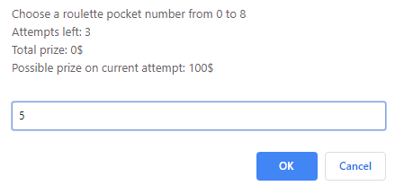

Figure 1 – The prompt window